**PEST SURVEY DATA OF REGION VIII (EASTERN VISAYAS)**

May 2024

**Monitoring date:** May 2-15, 2024

**Provinces surveyed:** Leyte, Southern Leyte, Samar, Eastern Samar, and Biliran.

**Number of Monitoring fields:** 248 monitoring fields (165 at fallow period, 33 just harvested, 22 at land preparation, 2 planted with other crops, 6 seedbeds, 20 planted with rice)

**Rice crop developmental stage:** Germination to milk stage.

**Data collector/s:** Ruby Teves, Raymart Pabuaya, Mohsen Sombrio, Shaina Plizardonaval, Ian Cesar Bula, Rolando Berwing, Nanette Lopez, Maria Diasanta, Claire Clement Opimo, Jo-Ann Arcibal, Jacinta Masendo, Mariz Anne Macaso, and Rex Socrates Altivo.

Table 1. List of monitoring fields with ≥5.00% average incidences on weed cover, and ≥3.00 insects per hill in Eastern Visayas on May 2024.

|  |  |  |  |
| --- | --- | --- | --- |
| **Field Code** | **Growth stage** | **Pest** | **Incidence (%)** |
| 080252 | Milk | Rice bug | 8.67 |
| 080078 | Tillering | Weeds | 13.33 |
| 080252 | Milk | Weeds | 15.00 |

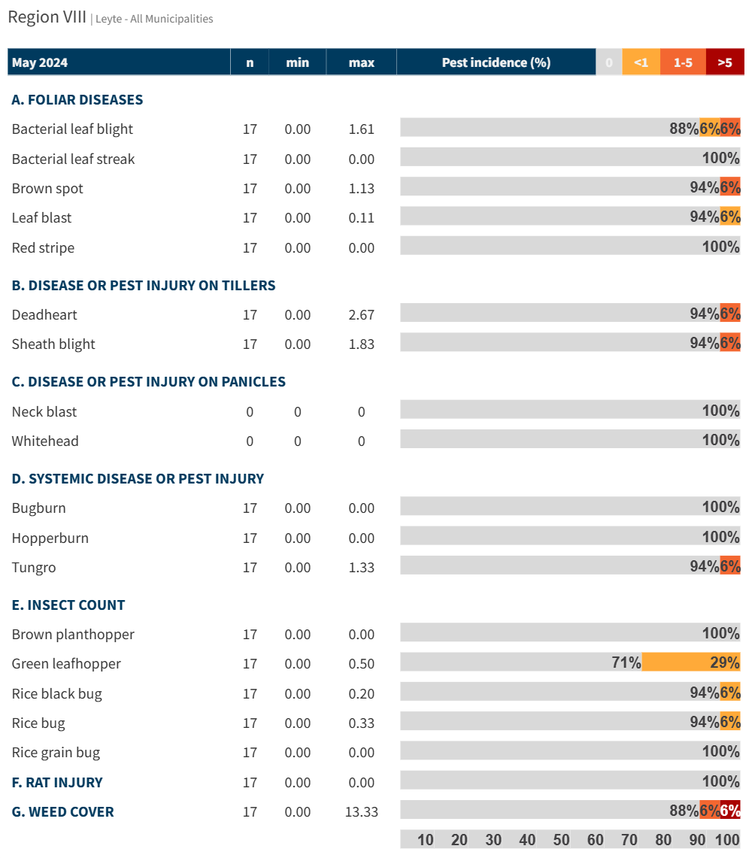

Figure 1. Incidence of pest injuries, counts of insect pests, and weed cover in Leyte on May 2024. Horizontal bar shows the proportion of fields in each range of pest injury incidence, insect count or weed cover.

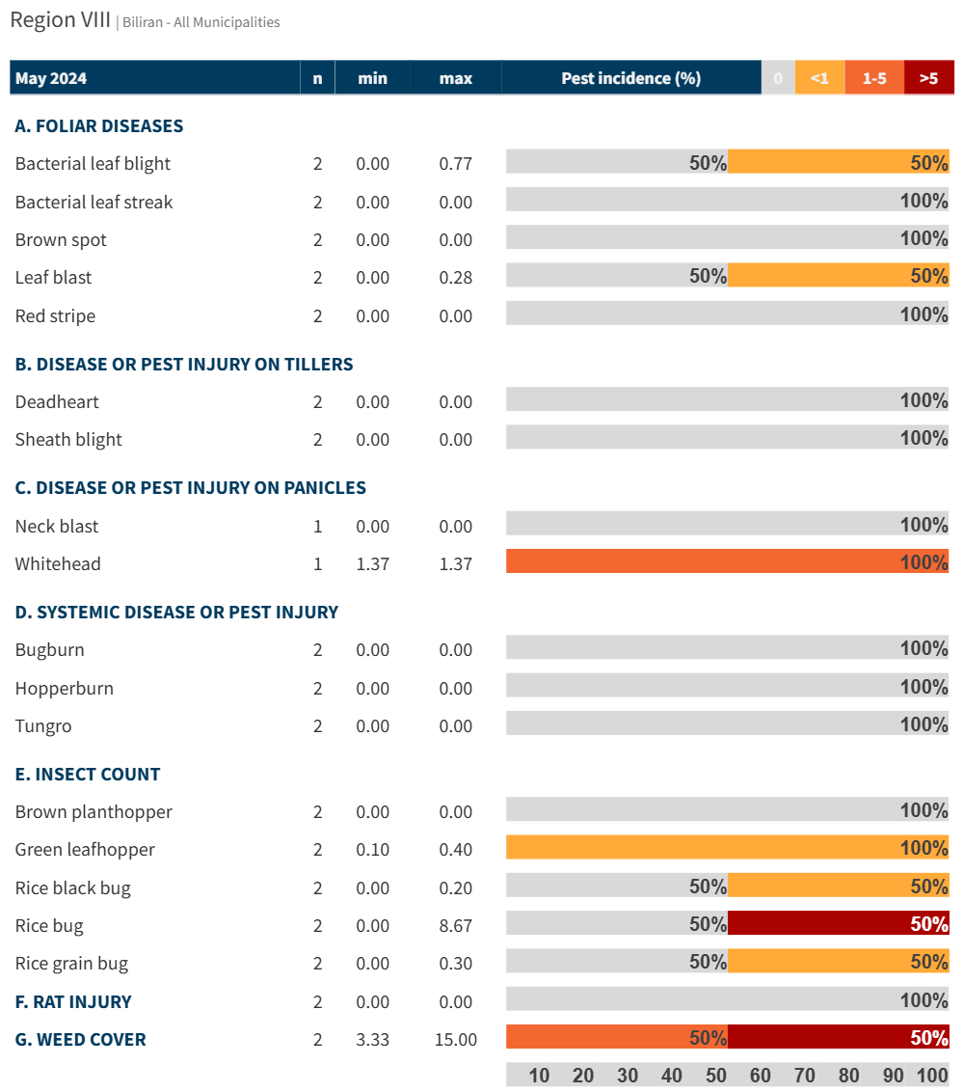

Figure 2. Incidence of pest injuries, counts of insect pests, and weed cover in Biliran on May 2024. Horizontal bar shows the proportion of fields in each range of pest injury incidence, insect count or weed cover.