**PEST SURVEY DATA OF REGION IV-B (MIMAROPA)**

May 2024

**Monitoring date:** May 1-16, 2024

**Provinces surveyed:** Oriental Mindoro, and Occidental Mindoro.

**Number of Monitoring fields:** 157monitoring fields (59 at fallow period, 48 just harvested, 33 at land preparation, 5 planted with other crops, 4 seedbeds, and 8 planted with rice)

**Rice crop developmental stage:** Germination to tilleringstage.

**Data collector/s:** Crispin Magluyan, Raffy Malimata, Crisner Carino, Jofel Barrion, Thomie Vidal, Romnick Esbieto, and Janmarc Tapales.

Table 1. List of monitoring fields with ≥5.00% average incidences on weed cover in MIMAROPA on May 2024.

|  |  |  |  |
| --- | --- | --- | --- |
| **Field Code** | **Growth stage** | **Pest** | **Incidence (%)** |
| 170043 | Tillering | Weeds | 5.00 |

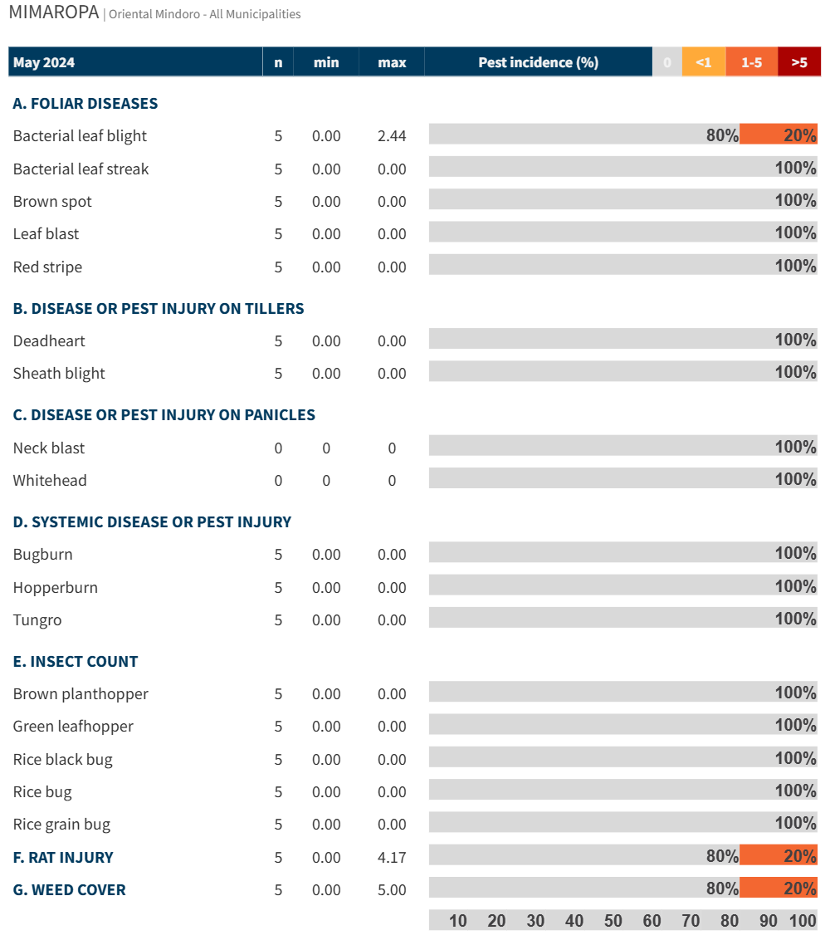

Figure 1. Incidence of pest injuries, counts of insect pests, and weed cover in Oriental Mindoro on May 2024. Horizontal bar shows the proportion of fields in each range of pest injury incidence, insect count or weed cover.