**PEST SURVEY DATA OF REGION XIII (CARAGA)**

May 2024

**Monitoring date:** May 2-14, 2024

**Provinces surveyed:** Agusan del Norte, Agusan del Sur, and Surigao del Sur.

**Number of Monitoring fields:** 139 monitoring fields (83 at fallow period, 6 just harvested, 39 at land preparation, 1 seedbed and 10 planted with rice)

**Rice crop developmental stage:** Seedling to maturity stage.

**Data collector/s:** Melindro Santaana, Alfie Aranzado, Ronald Busbus, Aldrin Añover, and Jeneviev Sajulga.

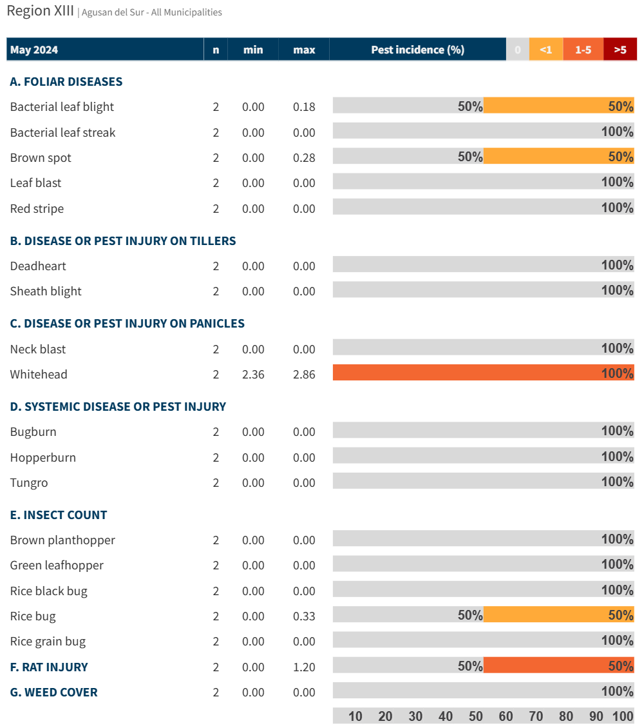

Figure 1. Incidence of pest injuries, counts of insect pests, and weed cover in on Agusan del Sur on May 2024. Horizontal bar shows the proportion of fields in each range of pest injury incidence, insect count or weed cover.

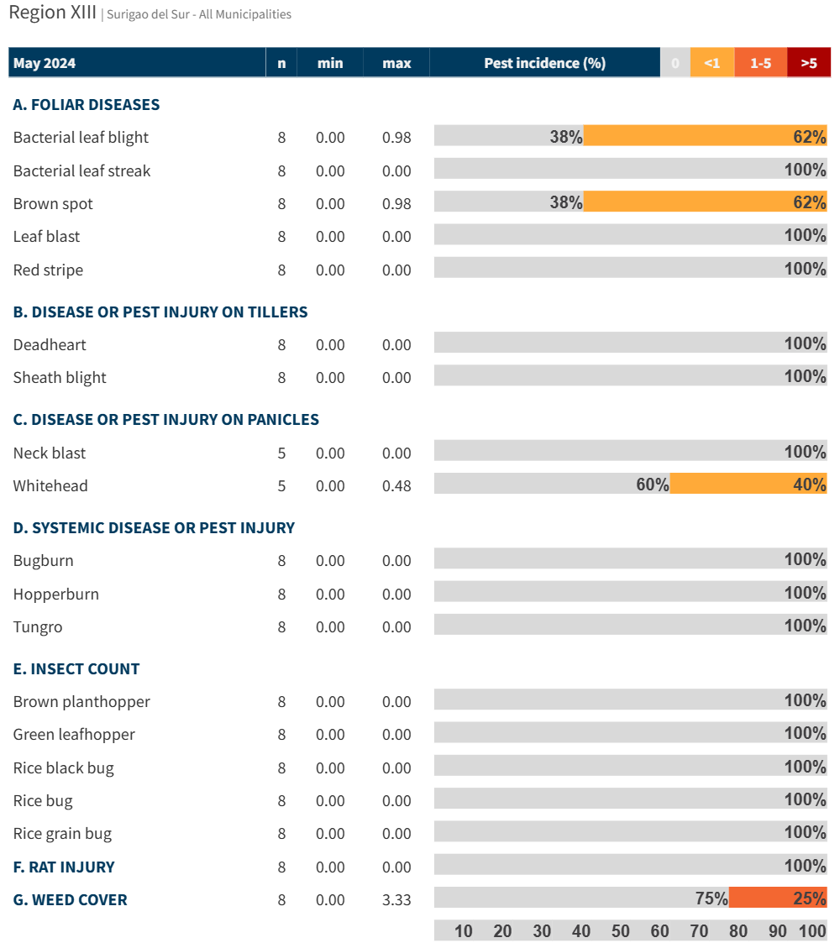

Figure 3. Incidence of pest injuries, counts of insect pests, and weed cover in on Surigao del Sur on May 2024. Horizontal bar shows the proportion of fields in each range of pest injury incidence, insect count or weed cover.